**ACTIVITY DIAGRAM**

**1)Darw a Activity drawn for online voting**

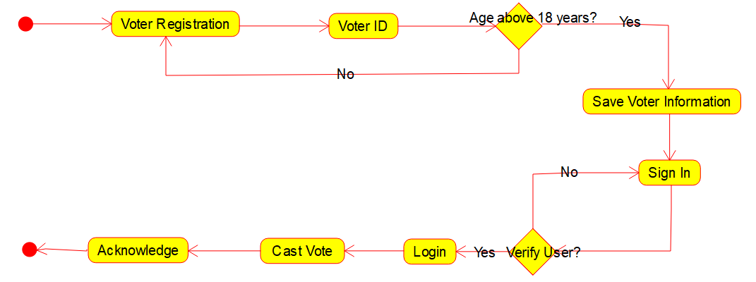

**2)Draw a activity diagram for library Management System**

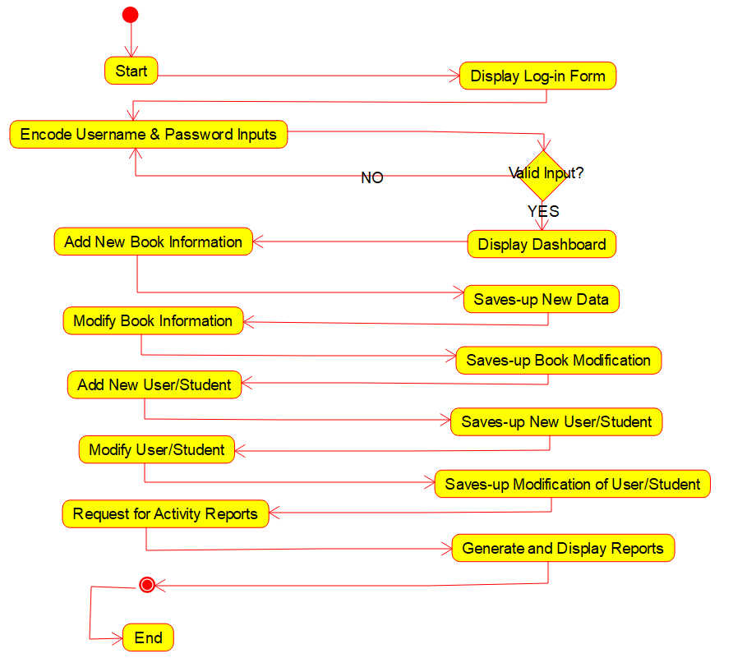

**3)Draw a activity diagram for online shopping System**

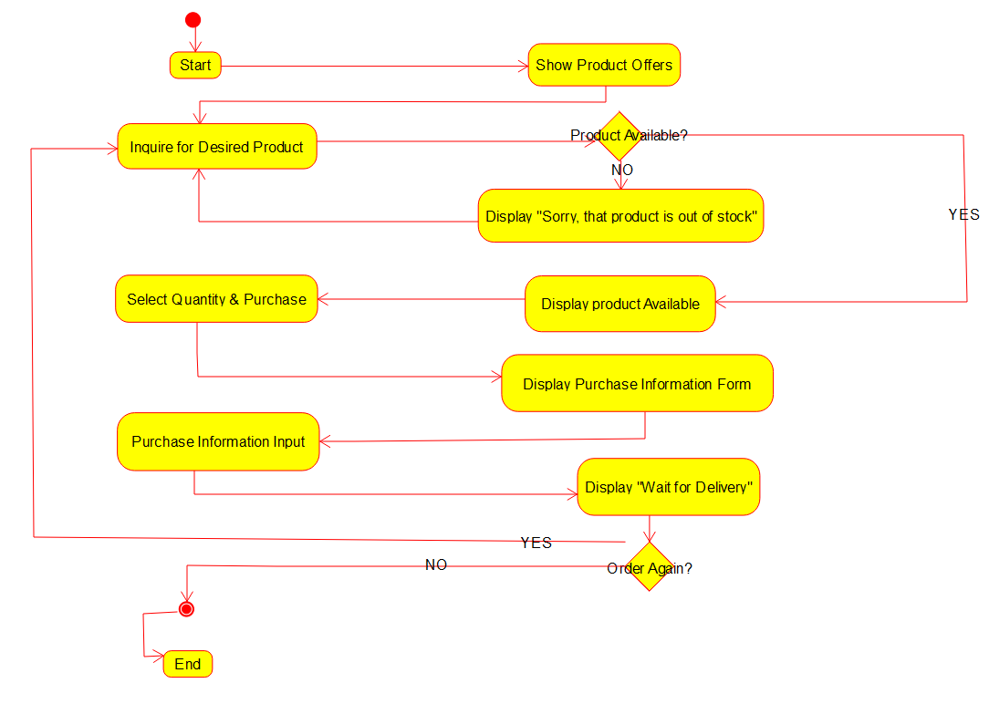

**4)Draw a activity Diagram for Online Banking System**

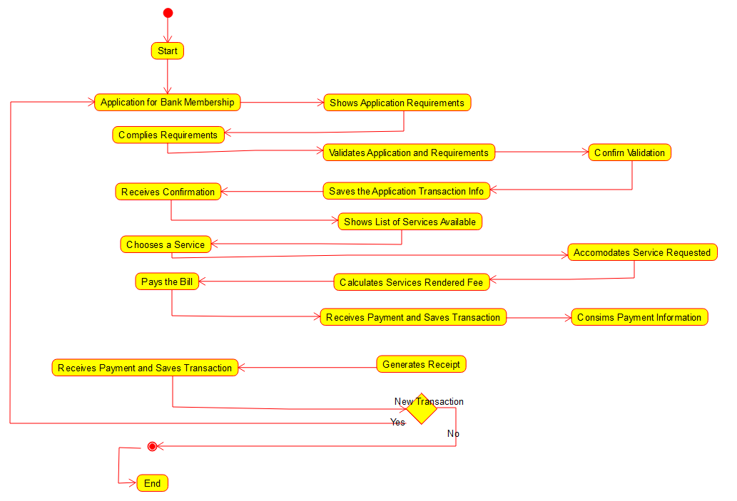

**5)Draw a Activity Diagram for E-Library**



**6)Draw a Activity diagram for railway reservation system**

